College of Fisheries, Mangalore 575002
‘Aquaclinics and Aquapreneurship Development’
Training Programme - Call for Applications
College of Fisheries, Mangalore in collaboration with ICAR-KVK(DK), Mangaluru is organizing a Four-week Training Programme on “Aquaclinics and Aquapreneurship Development” during January-February 2019. The programme is being sponsored by NFDB and MANAGE, Hyderabad. A total of 30 Candidates will be admitted to undergo this training programme. Graduates in Fisheries / Allied subjects / Diploma holders in Animal Husbandry / Agricultural Sciences are eligible to apply. Food and accommodation will be provided to the participants during the training programme and no course fee.
The applicants have to submit their duly filled-in application in the enclosed format to The Dean, College of Fisheries, Kankanady, Mangalore – 575 002 on or before 22nd December 2018.
Sd-
(Prof H Shivananda Murthy)
Dean (Fisheries)

 |  |  | 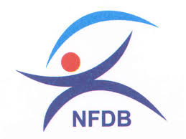 |  | 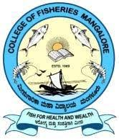
Application Form

1 | Name of the candidate
2 | Name of the father / Spouse
3 | Date of Birth
4 | Sex |  |  | Male / Female
5 | Permanent Address
 | Village and Panchayat
 | Block / Mandal
 | District
 | State
 | Pin Code
6 | Address for Correspondence
7 | Educational Qualification
 | Name of the Degree / Diploma / Certificate / Course
 | Board / Institute / University where studied
 | University to which affiliated
 | Marks / Grade obtained
 | Year of passing / completion
8 | Contact details
 | Telephone / Mobile
 | E-mail
9 | Experience in Fisheries and Aquaculture |  |  | Yes / No
10 | Interest to serve farmers for advisory services through Aqua One Centre / Aqua Clinics in serving farmers |  |  | Yes / No
Date Signature

